Skill Gap Analysis System

Business Requirements Document

Document Information and Approvals

Version History
Version # | Date |  | Revised By | Reason for change

Document Approvals
Approver Name | Project Role |  | Signature/Electronic Approval | Date

1. Scope 4
2. Overview 4
3. Pre-requisites 4
4. Features 4
4.1 Login screen 5
4.2 Home Page 5
4.3 Adding Employee Details 6
4.4 Adding Technology details 7
4.5 Creating Project Information 8
4.6 Creating Skill Gap Analysis 8
4.7 Report to View Skill Gap for selected project 9
5. System Flow 11
6. DB Design 12
7. JSON Mock Objects 12
8. Technologies / Infrastructure 14
9. Outcome Specification 14
10. References 15

Scope
Project Manager has set of Projects with specific team members and technologies across each project. Skill Gap Analysis system should assist manager to identify skill gap with in the team members of the project.

Overview
The System should provide Manager & Team Lead to configure data such as Adding Employees, Technologies and Projects and create/update project skill set and analyze the gaps among team members of the project. The system should generate Skill Gap analysis report for selected project.

Pre-requisites
- Database Tables must be created based on the details provided as part of DB Design section.
- Login & access permission needs to be checked from predefined User Mock JSON object.

Features
The system will provide the following features.
- Login Screen.
- Home Page.
- Adding Employee Details.
- Adding Technology details.
- Creating Project Information.
- Creating Skill Gap Analysis.
- Report to View Skill Gap for selected project.

Login screen
        - User will login Application with user Name and Password
Mockup
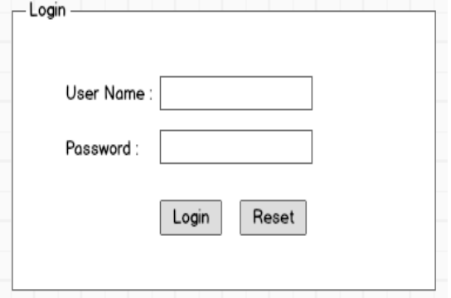
Validations:
      - User Name and Password are mandatory fields
      - Needs to validate the user & Password with set of users available in users JSON objects
      - Needs to display error message if user doesn't exists user/Password doesn't exists redirecting to login page
Users Mock JSON Object:
{ "users": [
{"userName": "Manager1","password": "testManager1","desg": 1 },
{"userName": "Manager2","password": "testManager2","desg":1},
{"userName": "temalead1","password": "testlead1","desg": 2},
{"userName": "temalead2","password": "testlead2","desg": 2}
]}

Home Page
        - User should be direct to Home page after login successfully
        - Based on user designation (Manager/Team Lead) respective landing page should be displayed
        - AngularJS Routers needs to be configured for redirecting to respective screens from home Page

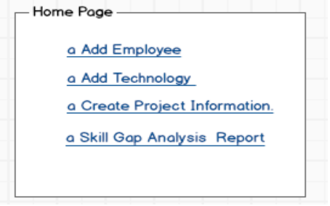
Manager Landing Page

Team Lead Landing Page
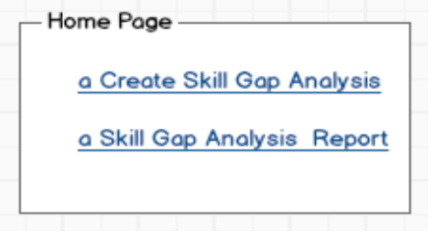

Adding Employee Details
        - ADD Employee screen access should be available for Manager.
        - Employee Name should be validated agonist existing records using Angular Built-in service before insert operation and should return message to user that employee name already exists
        - Designation selection box will have standard option name ,values
<select>
<option value="1">Manager</option>
<option value="2">Team Lead</option>
<option value="3">Developer</option>
</select>

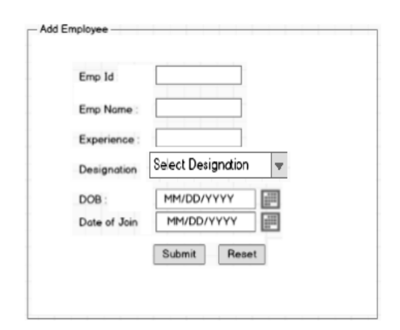
Mockup
Validations:
      - All the fields are mandatory
      - DOB field should valid data should be greater that equals to 20 years from current date
      - Date of join should not be greater than current date
      - Employee Id should be validated before insert and should return error message if Employee id already exists

Adding Technology details
        - Add Technology screen access should be available for Project Manager.
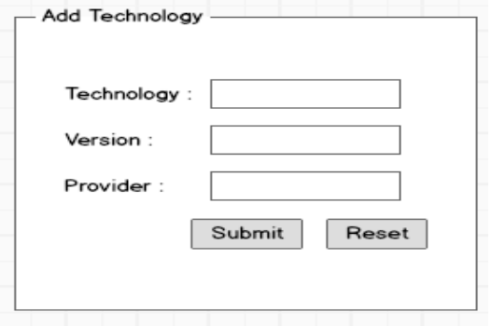
        - Data should be captured in SGA_TECHNOLOGIES table
Mockup

Validations:
      - All the fields are mandatory
      - Validation should be provided to check whether record with technology and version and should return message that Technology already exists

Creating Project Information
        - Create Project Information screen access should be available for Project Manager.
        - Screen should populate all the available Manager ,Team Lead, Employee, technologies information at loading the screen using angular Service
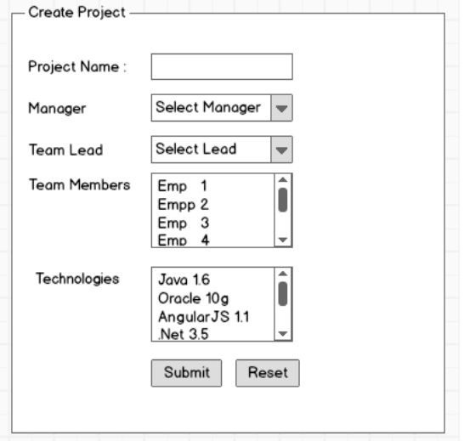
Mockup

Validations:
      - All the fields are mandatory
      - Project Name should be validated before performing insert operation using custom directive and should return error if project already exists
      - Project should have minimum one or more Team member and technology.

Creating Skill Gap Analysis
        - Create Skill Gap analysis screen access should be provided for Team Lead
        - once user select the project and click on generate system should populate the Employees and Technologies for selected project in vertical and horizontal view respectively
        - Default select option values at loading should be NA as select option value, following are standard values
<Select>
<option value="1">NA</option>
<option value="2">Yes</option>
<option value="3">NO</option>
</select>
        - user should be able to change the skill level for configured employees and technologies for selected project
        - If user click the save or update button data needs to save if records doesn't exists otherwise needs to update the existing records with new values
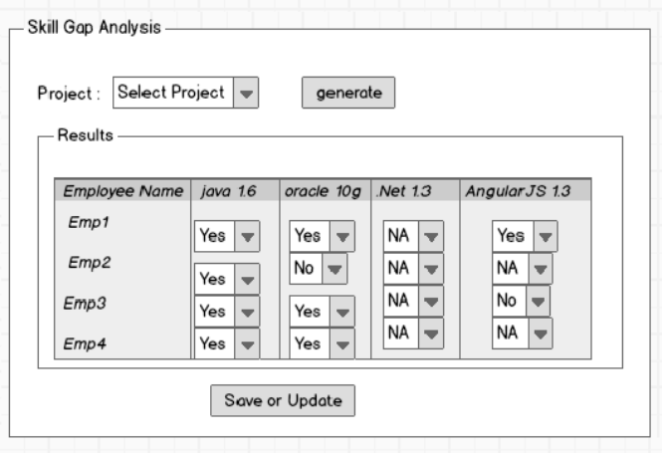
Mockup

Report to View Skill Gap for selected project
        - Skill Gap Analysis report access should be provided for Project Manager or Team Lead
        - System should generate the report for selected project as shown in Fig
        - Custom filter should be written to display Technology names in vertical view
        - Custom Directive should be written for display the skill level in standard color codes as per the skill level

Color Code | Skill Level
Green | 1
Red | 2
Yellow | 3

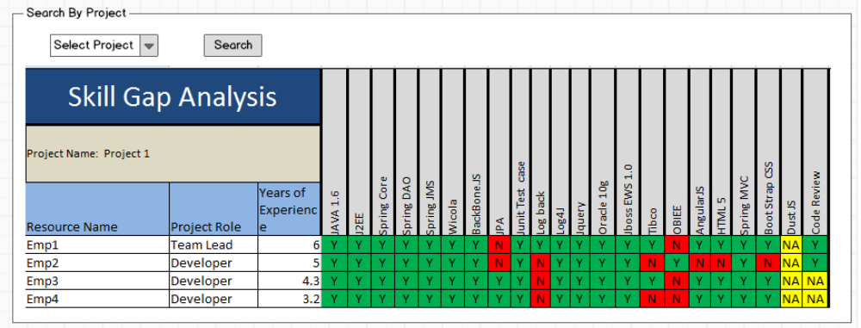
Mockup

System Flow
Admin screens
Adding Employee Details
Adding Technology details
Creating Project Information

Start
Login Screen
Valid User? ?
Error Message Login Failed
Role

Creating Skill Gap Analysis
Skill Gap Analysis Report
End

Manager/Team Lead
Yes
Manager
No

DB Design

- SGA_EMP Table

- Fields: EMPID,NAME,EXP,DESG,BOD,JOIN_DATE,LAST_MDFD_TMST
- Constraints:
  - PRIMARY KEY: EMPID
  - NOT NUL : NAME, LAST_UPTD_TMST

- SGA_TECHNOLOGIES Table

- Fields: ID,NAME,VERSION,VENDOR,LAST_MDFD_TMST
- Constraints:
  - PRIMARY KEY: ID auto Increment Value(Sequence)
  - NOT NULL: NAME,VERSION, LAST_UPTD_TMST
  - UNIQUE : NAME, VERSION

- SGA_PROJ_INFO Table

- Fields: ID,NAME,REPORT_MNGR,REPORT_TL,LAST_MDFD_TMST
- Constraints:
  - PRIMARY KEY : ID auto Increment Value(Sequence)
  - NOT NULL: NAME, LAST_UPTD_TMST
  - UNIQUE : NAME

- SGA_PROJ_SKILL Table

- Fields: ID, PROJ_ID, EMP_ID, TECH_ID,SKILL_LEVEL ,
LAST_MDFD_TMST
- Constraints:
  - PRIMARY KEY :PROJ_ID, EMP_ID, TECH_ID (Composite Key)
  - NOT NULL: LAST_UPTD_TMST
  - Default : SKILL_LEVEL (1)

JSON Mock Objects

Employees

{ "employees": [
{ "empId": "101", "empName": "John","experience": "5.6", "desg": "1", "DOB": "03/20/1984","DOJ": "09/15/2010"},
{"empId": "102","empName": "Mike","experience": "7","desg": "2", "DOB": "05/10/1980","DOJ": "09/15/2012"},
{ "empId": "103","empName": "Peter","experience": "3.0","desg": "3", "DOB": "03/20/1982","DOJ": "09/15/2013" },
{"empId": "104","empName": "Harry","experience": "3.0","desg": "3","DOB": "03/20/1982", "DOJ": "09/15/2013"},
{"empId": "105","empName": "Smith","experience": "5.3","desg": "2","DOB": "03/20/1982","DOJ": "09/15/2009"},
{"empId": "98","empName": "Rick","experience": "7.5","desg": "1","DOB": "03/20/1975","DOJ": "09/15/2000"}
]}

Technologies

{ "technologies": [
{"name": "Java","version": "1.6","provider": "Sun Micro System"},
{"name": ".Net","version": "4.6","provider": "Microsoft Corp"},
{"name": "Oracle","version": "10g","provider": "Oracle Corp"},
{"name": "Java","version": "1.7","provider": "Sun Micro System"},
{"name": "AngularJS","version": "1.8","provider": "Google Corp"}
]}

Projects

{
"projects": [
{"name": "online Shopping","manager": "John","teamlead": "Mike",
"teamMembers": [
{"empId": "101","empName": "John","experience": "5.6","desg": "1","DOB": "03/20/1984", "DOJ": "09/15/2010"},
{"empId": "102","empName": "Mike","experience": "7","desg": "2","DOB": "05/10/1980", "DOJ": "09/15/2012"},
{"empId": "103", "empName": "Peter", "experience": "3.0", "desg": "3","DOB": "03/20/1982","DOJ": "09/15/2013"}
],
"technologies": [
{"name": "Java","version": "1.7","provider": "Sun Micro System"},
{"name": "AngularJS","version": "1.8","provider": "Google Corp"}
]
},
{"name": "Retail Marketing","manager": "Rick","teamlead": "Smith",
"teamMembers": [
{"empId": "98","empName": "Rick","experience": "7.5","desg": "1","DOB": "03/20/1975", "DOJ": "09/15/2000"},
{"empId": "104","empName": "Harry","experience": "3.0","desg": "3","DOB": "03/20/1982","DOJ": "09/15/2013"},
{"empId": "105","empName": "Smith","experience": "5.3","desg": "2","DOB": "03/20/1982","DOJ": "09/15/2009"}
],
"technologies": [
{"name": ".Net","version": "4.6","provider": "Microsoft Corp"},
{"name": "Oracle", "version": "10g","provider": "Oracle Corp"},
{"name": "AngularJS","version": "1.8","provider": "Google Corp"}
]
}
]
}

Technologies / Infrastructure
- Java 1.6
- AngularJS 1.0.8
- HTML 5
- Spring
- Maven
- Jetty
- MySQL
- AngularJS Testing framework

Outcome Specification
- Should follow Angular JS MVC pattern
- Should not use any JSP/Spring tag library as part of view
- Should use AngularJS in built & custom directives, Filters and services.
- View should be designed to render the Model object provided by controller.
- All the logic to Manipulate model should be handled in controller.
- Controller should communicate to Service for required model object
- Should not use any jQuery functionality and make use of built-in AngularJS functions
- Test cases should be designed for the controllers, directives using Angular JS Testing framework

References
- Example Skill Gap Analysis outcome JSON Object
{
"SkilGapAnalysis": [
{"projname": "online Shopping",
"teamMembers": [
{"empId": "101","empName": "John","experience": "5.6","desg": "1",
"skillAnalysis": [
{ "techName": "Java", "version": "1.7","skilllevel": "1"},
{"techName": "AngularJS","version": "1.8","skilllevel": "1"},
{"techName": "Java","version": "1.7","skilllevel": "1"}
] },
{ "empId": "102","empName": "Mike","experience": "7","desg": "2",
"skillAnalysis": [
{"techName": "Java","version": "1.7","skilllevel": "1"},
{"techName": "AngularJS","version": "1.8","skilllevel": "1"},
{"techName": "Java","version": "1.7", "skilllevel": "3"}
] },
{"empId": "103","empName": "Peter","experience": "3.0","desg": "3",
"skillAnalysis": [
{"techName": "Java","version": "1.7", "skilllevel": "1"},
{"techName": "AngularJS","version": "1.8","skilllevel": "3"},
{"techName": "Java","version": "1.7", "skilllevel": "2"}

]} ] }]}

